**ANAYA**

**Home Page:**

Banner slider images

Size: 480x480 px

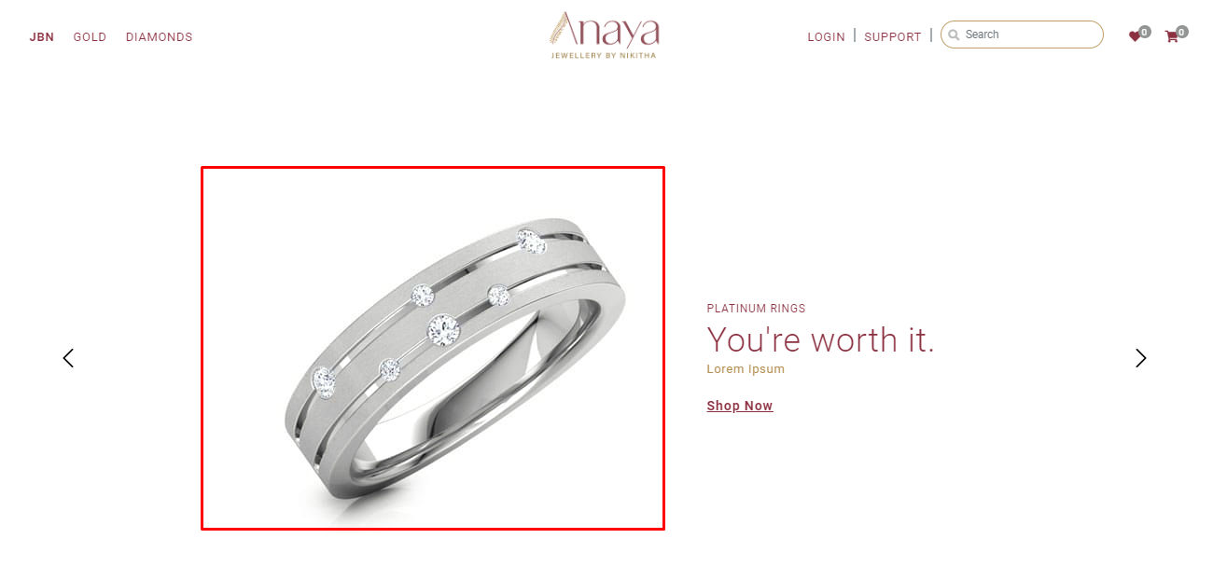

New arrivals

Size: 850x850

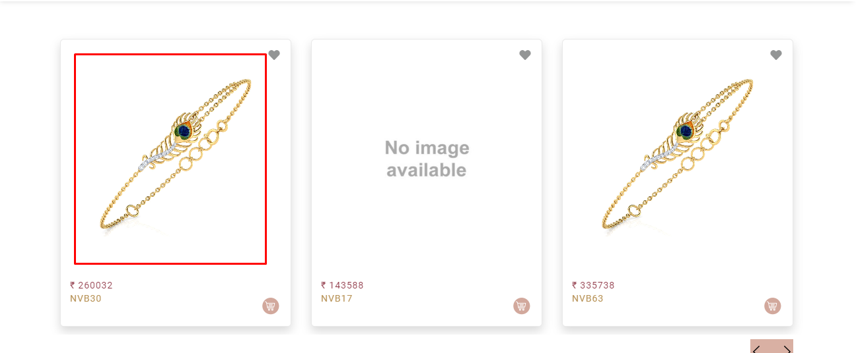

Benefits

Size: 60x60

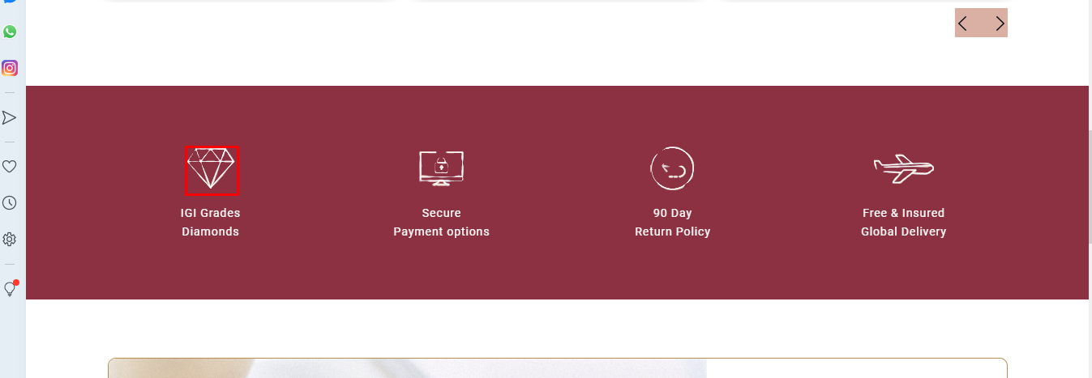

Add Banners

Size: 990x450 px

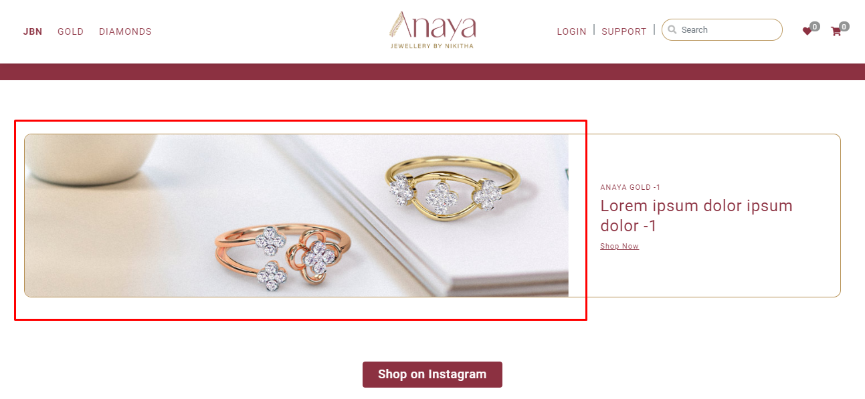

Footer Icons

Size: 22x22 px

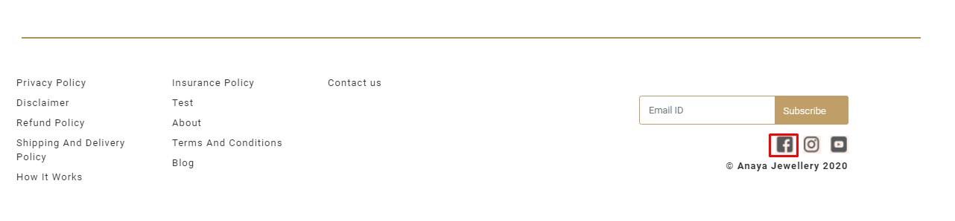

**Category Page:**

Banner image

Size:1920x350 px

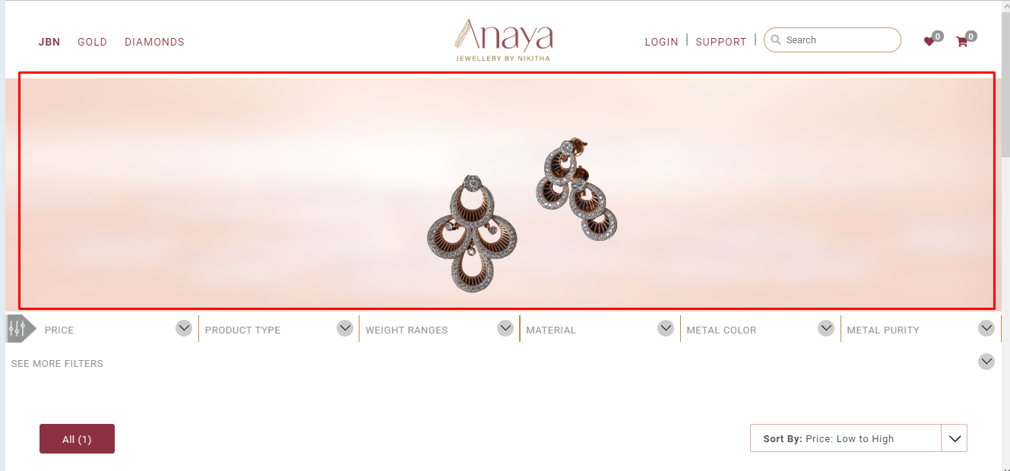

Product image

Size: 850x850 px

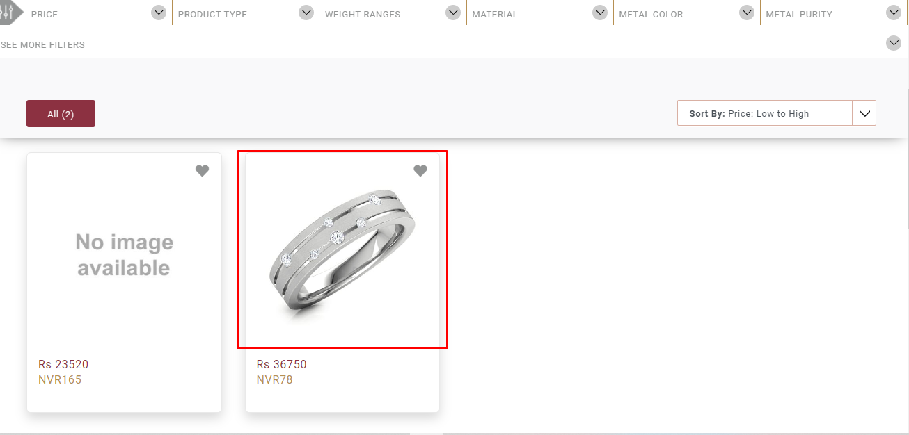

**About us Page:**

Banner Image

Size: 1170x350 px



Our Team

Size: 500x400 px

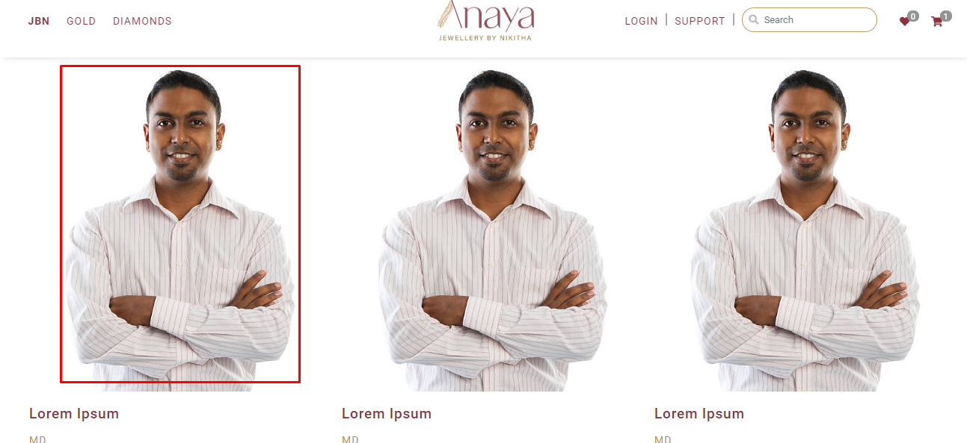

**Blog Page:**

Banner Image

Size: 1170x 350 px

